ASSIGNMENT – 15.4
Shaik Sohail
2303A52231
BATCH 44

Task1:
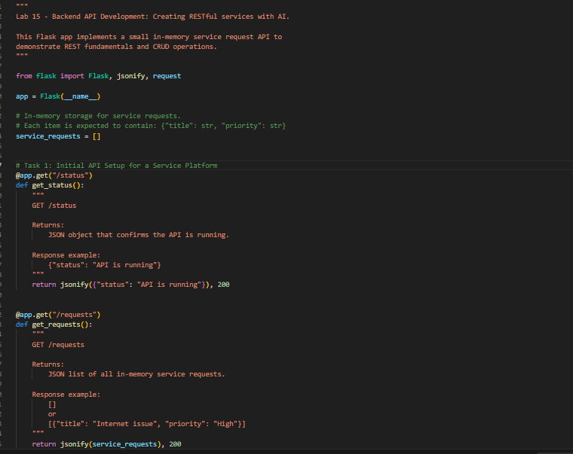

Output:
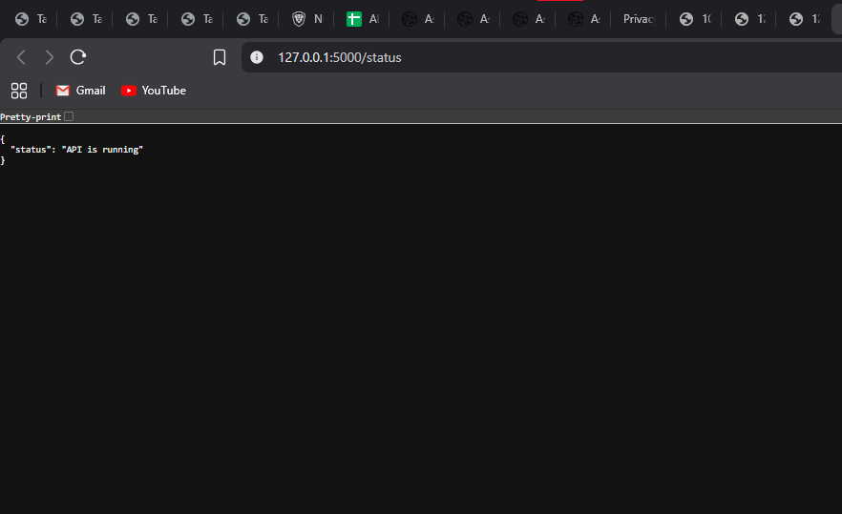
Task 1 observation: The Flask API was initialized successfully, and the status route confirmed that the backend was live and reachable. The server ran locally without errors, which established a stable base for implementing the remaining tasks.

TASK 2:
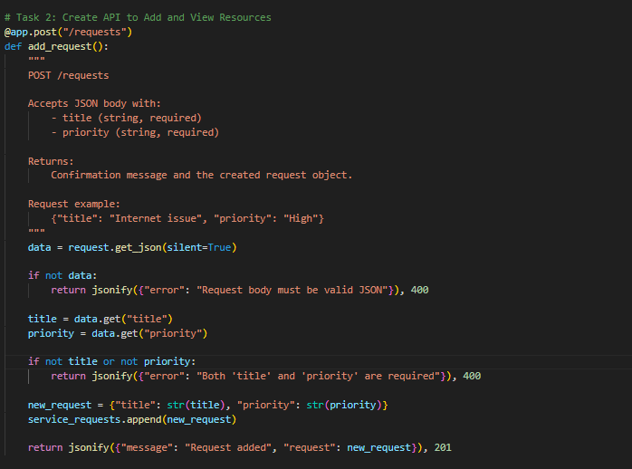
OUTPUT:
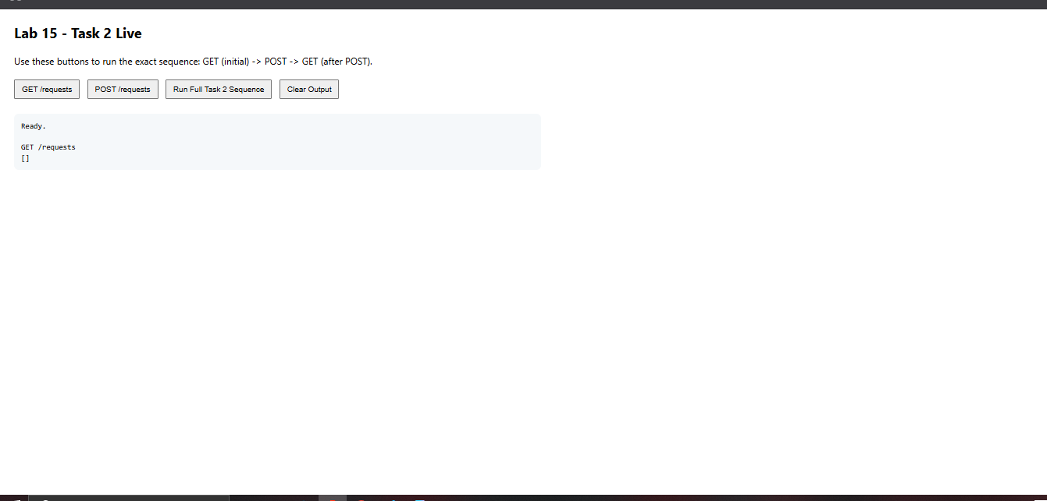
Task 2 observation: The requests endpoint initially returned an empty list, confirming that in-memory storage started cleanly. After sending a POST request with title and priority, the API correctly returned a confirmation message along with the created object, and a subsequent GET request showed that the new request had been stored properly, validating both create and read operations.

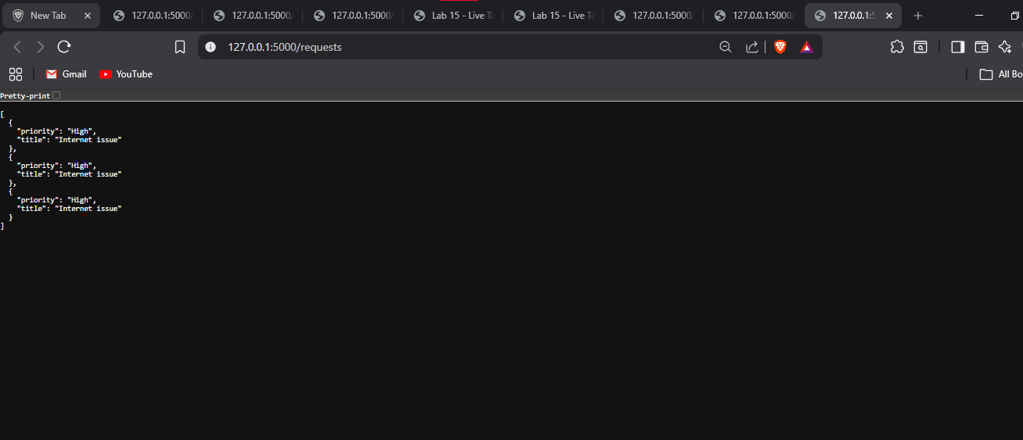
TASK3:
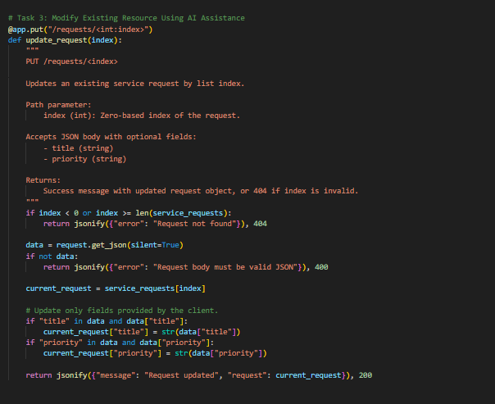
OUTPUT:

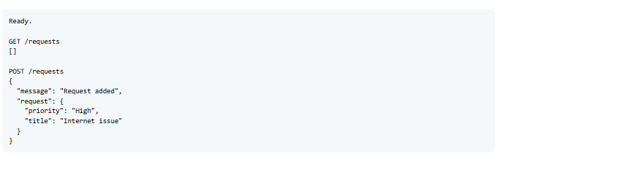
Task 3 observation: Updating a request through a valid index worked as expected, and the response returned the updated object with a clear success message. When an invalid index was used, the API responded with a proper not-found error, showing that update logic and boundary checking were handled safely.

TASK 4:
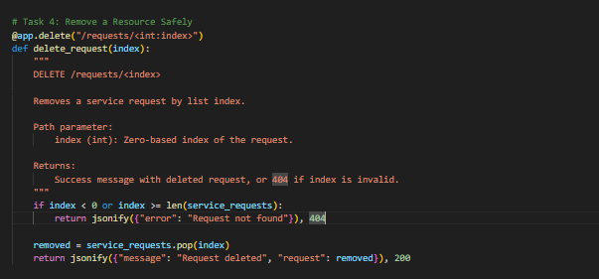

OUTPUT:
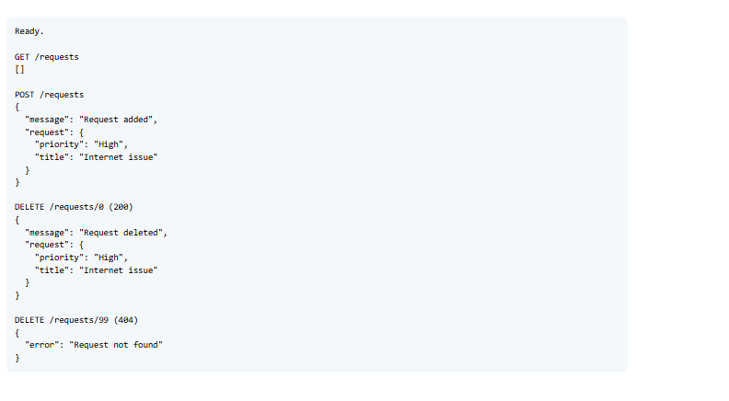
Task 4 observation: Deleting a request by valid index removed the item correctly and returned deleted data in the response, confirming expected delete behavior. Attempting to delete with an invalid index produced a clear error response without crashing the server, which demonstrated safe deletion and reliable error handling.

TASK 5:
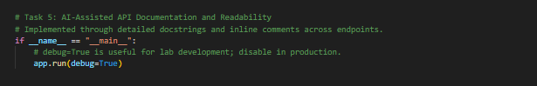
OUTPUT:
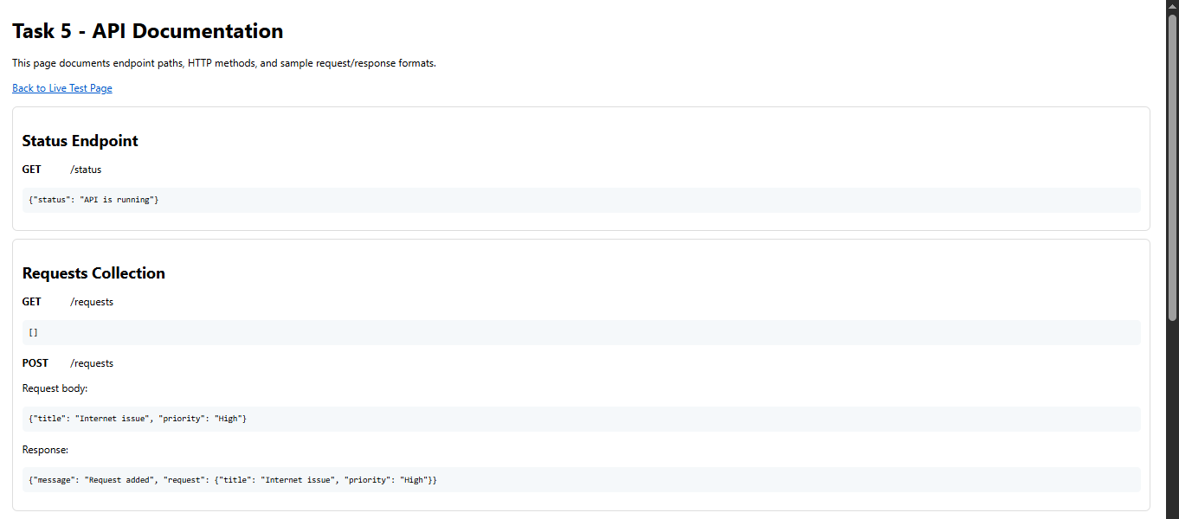
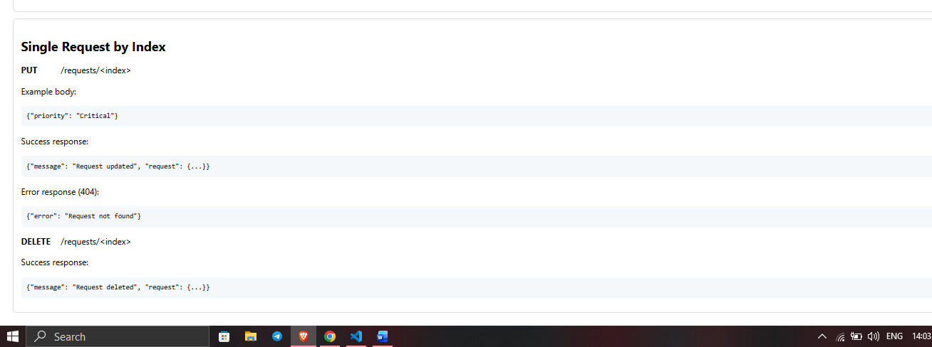
Task 5 observation: The API became much easier to understand after adding meaningful docstrings and inline comments for methods, inputs, and responses. A live documentation-style page was also provided to display endpoint paths, HTTP methods, and sample request/response formats, improving readability and making demonstration and reporting more effective.

